Software Requirements Specification
for
<ICCR webpage >
Version 1.0 approved
Prepared by <author>
<organization>
<date created>
Table of Contents
Table of Contents ii
Revision History ii
1. Introduction 1
1.1 Purpose 1
1.2 Document Conventions 1
1.3 Intended Audience and Reading Suggestions 1
1.4 Product Scope 1
1.5 References 1
2. Overall Description 2
2.1 Product Perspective 2
2.2 Product Functions 2
2.3 User Classes and Characteristics 2
2.4 Operating Environment 2
2.5 Design and Implementation Constraints 2
2.6 User Documentation 2
2.7 Assumptions and Dependencies 3
3. External Interface Requirements 3
3.1 User Interfaces 3
3.2 Hardware Interfaces 3
3.3 Software Interfaces 3
3.4 Communications Interfaces 3
4. System Features 4
4.1 System Feature 1 4
4.2 System Feature 2 (and so on) 4
5. Other Nonfunctional Requirements 4
5.1 Performance Requirements 4
5.2 Safety Requirements 5
5.3 Security Requirements 5
5.4 Software Quality Attributes 5
5.5 Business Rules 5
6. Other Requirements 5
Appendix A: Glossary 5
Appendix B: Analysis Models 5
Appendix C: To Be Determined List 6

Revision History
Name | Date | Reason For Changes | Version

Introduction

Purpose
<Identify the product whose software requirements are specified in this document, including the revision or release number. Describe the scope of the product that is covered by this SRS, particularly if this SRS describes only part of the system or a single subsystem.>

ICCR main objective is to monitor all its Regional Offices (ROs) in India on real-time basis for all the activities they conduct, which would ultimately help ICCR to implement its activities effectively and efficiently and thus, evaluate their performances on real-time basis.

Document Conventions
<Describe any standards or typographical conventions that were followed when writing this SRS, such as fonts or highlighting that have special significance. For example, state whether priorities for higher-level requirements are assumed to be inherited by detailed requirements, or whether every requirement statement is to have its own priority.>
This document uses the following conventions.
Fonts
Management and evaluation

Intended Audience and Reading Suggestions
<Describe the different types of reader that the document is intended for, such as developers, project managers, marketing staff, users, testers, and documentation writers. Describe what the rest of this SRS contains and how it is organized. Suggest a sequence for reading the document, beginning with the overview sections and proceeding through the sections that are most pertinent to each reader type.>
The intended audience who will be mainly using our system are ICCR, Ros, Students and Institutes.
ICCR is the primary stakeholder with a separate dashboard to manage Regional Offices and evaluate their activities.
RO’s will be provided with a dashboard to schedule activities, upload reports for the activities conducted and manage students and handle their grievances.
Institutes will be provided funds by the ICCR to conduct cultural events at the institute level.
Students will

Product Scope
<Provide a short description of the software being specified and its purpose, including relevant benefits, objectives, and goals. Relate the software to corporate goals or business strategies. If a separate vision and scope document is available, refer to it rather than duplicating its contents here.>

Monitoring and evaluating all activities of ICCR’s Regional Offices and evaluate their performances on real-time basis.
• Look after the interest of foreign students studying in various states of India.
• Keep track of Monetary Information spent on students and other establishment expenditure.
• Develop mechanism to coordinate with local cultural and educational organizations and the State Government for carrying out ICCR’s mandate of activities

References
<List any other documents or Web addresses to which this SRS refers. These may include user interface style guides, contracts, standards, system requirements specifications, use case documents, or a vision and scope document. Provide enough information so that the reader could access a copy of each reference, including title, author, version number, date, and source or location.>
- Indian Council for Cultural Relations, Wikipedia, https://en.wikipedia.org/wiki/Indian_Council_for_Cultural_Relations#Publications, Oct 3,2022
- Official website of Indian Council for Cultural Relations, Government of India, https://iccr.gov.in/about-us, Oct 3,2022
- ICCR Annual Report: Indian Council for Cultural Relations Azad Bhawan, I.P. Estate, New Delhi, 2020-21

Overall Description

Product Perspective
<Describe the context and origin of the product being specified in this SRS. For example, state whether this product is a follow-on member of a product family, a replacement for certain existing systems, or a new, self-contained product. If the SRS defines a component of a larger system, relate the requirements of the larger system to the functionality of this software and identify interfaces between the two. A simple diagram that shows the major components of the overall system, subsystem interconnections, and external interfaces can be helpful.>
It is a web portal with separate dashboards for each stakeholder(ICCR,Ros,…) whose main objective is to monitor and evaluate the cultural activities in the institutes and provide them with funds and special performance ratings for their events.
At the same time making the students aware about Indian cultures as well as the foreign students by proving them with scholarships to study our culture of India. Spread, maintain relations with other countrries

Product Functions
<Summarize the major functions the product must perform or must let the user perform. Details will be provided in Section 3, so only a high level summary (such as a bullet list) is needed here. Organize the functions to make them understandable to any reader of the SRS. A picture of the major groups of related requirements and how they relate, such as a top level data flow diagram or object class diagram, is often effective.>
Main Functionalities of this portal are :
Facility of generating the monthly activity report based on activities conducts or events organized at the institute level.
Generating feedback form links for sharing it amongst participants of events to collect their review and feedback of the evnts organized to better perform next time.

User Classes and Characteristics
<Identify the various user classes that you anticipate will use this product. User classes may be differentiated based on frequency of use, subset of product functions used, technical expertise, security or privilege levels, educational level, or experience. Describe the pertinent characteristics of each user class. Certain requirements may pertain only to certain user classes. Distinguish the most important user classes for this product from those who are less important to satisfy.>

The first-class users will be:
ICCR , RO(primary users)

Institutes (secondary users) bcoz they will be uploading the documents for ICCR abd will be directly receiving funds based on…..

Students (secondary ) bcoz they have the only role to fill the feedback form and provide their review for the events organized.,scholarshoip info and apply

Operating Environment
<Describe the environment in which the software will operate, including the hardware platform, operating system and versions, and any other software components or applications with which it must peacefully coexist.>
Our project works on windows version 7 and above, mac os ,linux

Design and Implementation Constraints
<Describe any items or issues that will limit the options available to the developers. These might include: corporate or regulatory policies; hardware limitations (timing requirements, memory requirements); interfaces to other applications; specific technologies, tools, and databases to be used; parallel operations; language requirements; communications protocols; security considerations; design conventions or programming standards (for example, if the customer’s organization will be responsible for maintaining the delivered software).>

Language constarints (english) iccr will responsible for maintaining the delivered software

User Documentation
<List the user documentation components (such as user manuals, on-line help, and tutorials) that will be delivered along with the software. Identify any known user documentation delivery formats or standards.>

Assumptions and Dependencies
<List any assumed factors (as opposed to known facts) that could affect the requirements stated in the SRS. These could include third-party or commercial components that you plan to use, issues around the development or operating environment, or constraints. The project could be affected if these assumptions are incorrect, are not shared, or change. Also identify any dependencies the project has on external factors, such as software components that you intend to reuse from another project, unless they are already documented elsewhere (for example, in the vision and scope document or the project plan).>
Institute account RO accounts , students should be registered
Internet connectivity

External Interface Requirements

User Interfaces
<Describe the logical characteristics of each interface between the software product and the users. This may include sample screen images, any GUI standards or product family style guides that are to be followed, screen layout constraints, standard buttons and functions (e.g., help) that will appear on every screen, keyboard shortcuts, error message display standards, and so on. Define the software components for which a user interface is needed. Details of the user interface design should be documented in a separate user interface specification.>
All stakeholders have separate dashboard and navigate easy or for smooth flow.

Hardware Interfaces
<Describe the logical and physical characteristics of each interface between the software product and the hardware components of the system. This may include the supported device types, the nature of the data and control interactions between the software and the hardware, and communication protocols to be used.>
Our project works on windows version 7 and above, mac os ,linux

Software Interfaces
<Describe the connections between this product and other specific software components (name and version), including databases, operating systems, tools, libraries, and integrated commercial components. Identify the data items or messages coming into the system and going out and describe the purpose of each. Describe the services needed and the nature of communications. Refer to documents that describe detailed application programming interface protocols. Identify data that will be shared across software components. If the data sharing mechanism must be implemented in a specific way (for example, use of a global data area in a multitasking operating system), specify this as an implementation constraint.>
Feedback : student give feedback to institute.
Reports: input Ro and give Institute

Communications Interfaces
<Describe the requirements associated with any communications functions required by this product, including e-mail, web browser, network server communications protocols, electronic forms, and so on. Define any pertinent message formatting. Identify any communication standards that will be used, such as FTP or HTTP. Specify any communication security or encryption issues, data transfer rates, and synchronization mechanisms.>

Communication channel between all the stockholders for effective running of the system.
And also for checking that the information provides is authentic for not.

System Features
The section illustrates the functional requirements for the product and the major services provided by the product.

Functional Requirement

REQ-1: Login for the stakeholder:
All the stakeholder will separate login.

REQ-2: Stakeholder will be provided with separate dashboard.

REQ-3: Monitoring and Evaluation of reports:
All the monthly reports provided by the RO will be helpful to monitor whether the activities are properly conducted or not and would be evaluated by the ICCR.

REQ-4: Rating mechanism:
The RO and institutes will get ratings after evaluation of the reports.

REQ-5: Evaluation by RO:
- The RO would evaluate the report submitted by the institutions and provide funds to conduct more of such activities.
- RO will get all the details of the activity conducted in the report.

REQ-6: Student module:
  - Student will get all relevant information of upcoming activities.
  - Student can also get information of previous activities.
  - Applications for scholarship would be made available to the students.
  - Feedback form for the activity would be provided.

Other Nonfunctional Requirements

Performance Requirements
- The report uploaded by the Institution or RO should not be larger than 50 MB.
- Smooth working of website is must to ensure good user experience.
- Server will be working 24X7.

Safety Requirements
- Access to unauthorized student would be prevented.
- Student will not be a part in making or editing activity report.
- No one other than RO and ICCR would have access to institute reports.

Security Requirements
- Access to unauthorized student would be prevented, same for the Institute as well.
- Student should be enrolled in the institute to fill the feedback form and apply for scholarship.
- Only authorized student would be able to apply for scholarship and fill the feedback.
- Only ICCR would have access to monitor and evaluate the monthly activity reports of RO.

Software Quality Attributes
- Map is an additional feature that provide information of RO’s in India.
- The System is easy to maintain.

Other Requirements
Appendix A: Glossary
ICCR: Indian Council for Cultural Relations.
RO: Regional offices.
Activity: Events, work determined by ICCR.

Appendix B: Analysis Models

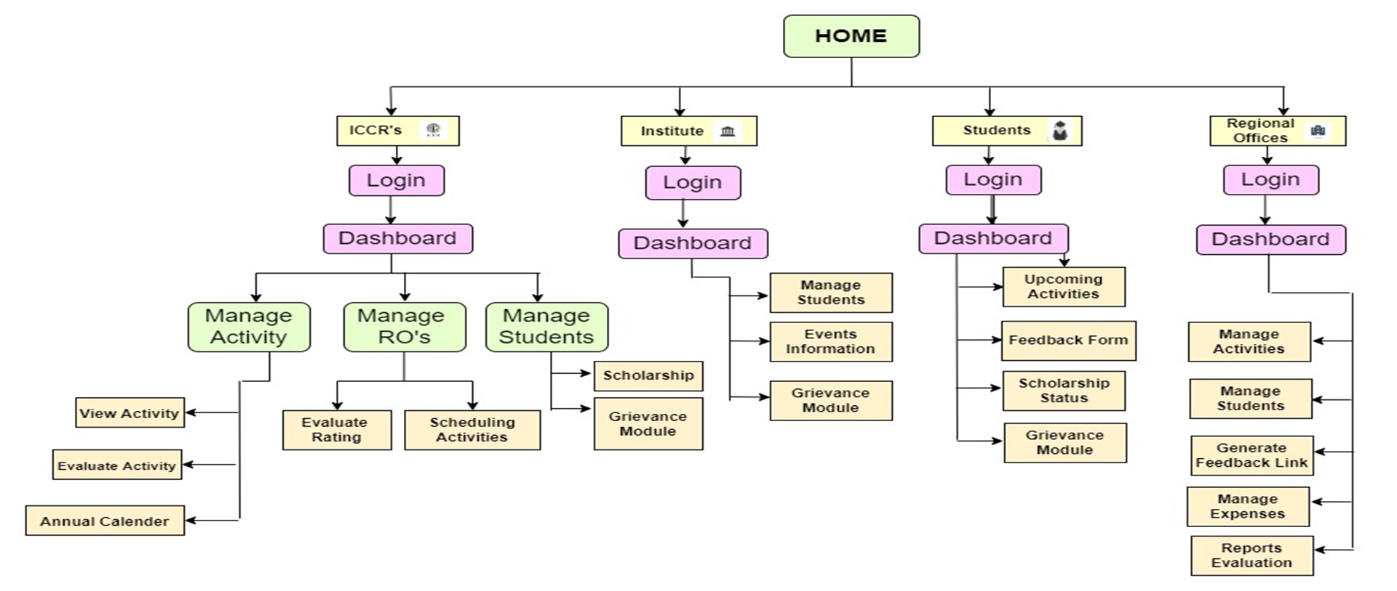

Appendix C: To Be Determined List
<Collect a numbered list of the TBD (to be determined) references that remain in the SRS so they can be tracked to closure.>

